**SECTION A**

**SUB SECTION I**

**Questions 1 to 50 carry one mark each.**

***In each of the questions 1 to 50, fill in the blank spaces with a suitable word.***

1. The school library is ............................. to the new washrooms.
2. Wujuwe has ............................. the case to police by himself.
3. There were very many .............................. who came to watch the netball match.
4. Mr. Sempa is ............................. to attend my parents’ wedding ceremony next week.
5. We should always obey and respect .........................elders.

***In each of the questions 6 – 15, use the correct form of the word given in brackets to complete the sentence.***

1. The customer ............................ a prayer before having her lunch at the hotel. (say)
2. Nyaps ............................ opposed the idea of cleaning the forest. (strong)
3. Our teacher usually gives us good pieces of ........................ during his lessons. (advise)
4. Kadama has just ......................... some money from his bank account. (withdraw)
5. Some of the ............................ did not know how to use the microphone. (speak)
6. It is advisable for learners to pay ............................ to their teachers. (attentive)
7. This area is ............................ than our village because it is near a lake. (swampy)
8. Haruna Matata was ........................ on the left ear by a mosquito. (bite)
9. Candidates must be allowed to ............................ themselves after their Primary Leaving Examinations. (joy)
10. May I borrow ............................ dictionary please? (you)

***In questions 16 and 17, arrange the given words in alphabetical order.***

1. sunny, cloudy, windy, rainy

..........................................................................................................................

1. humps, helmet, hour, hammer

...........................................................................................................................

**In questions 18 and 19, rearrange the given words to form a correct sentence.**

1. the Don’t running cross while road.

...........................................................................................................................

1. family does How their have members many?

...........................................................................................................................

***In questions 20 and 21, write the full forms of the given short forms.***

1. neg. ................................................................................................................
2. Let’s ................................................................................................................

***In questions 22 and 23, rewrite the sentence giving the opposite of the underlined words.***

1. Atanaka’s phone has a **bright** screen.

...........................................................................................................................

1. She will **die** if she ensures good health.

...........................................................................................................................

***In questions 24 and 25, give the singular form of the given words.***

1. masters of ceremonies ......................................................................................
2. eyelashes .........................................................................................................

***In questions 26 and 27, use each of the given words in a sentence to show that you know the difference in their meaning.***

1. back

...........................................................................................................................

1. bark

...........................................................................................................................

***In each of the questions 28 - 30, rewrite giving one word for the underlined group of words.***

1. The beautiful girl has gone up the mountain.

...........................................................................................................................

1. Ankunda Job speaks to her friends with humility.

...........................................................................................................................

1. Every pupil is home because it is a Saturday and Sunday.

...........................................................................................................................

**SUB SECTION II**

***In each of the questions 31 to 50, rewrite the sentence as instructed in brackets.***

1. Reading newspapers is interesting. It is also educative.

(Join the sentences using: ……….not only……….)

.…………………………………………………………………………………………………………………………

………………………………………………………………………………………………………………………….

1. Elizabeth is not as fast as Anabel.(Rewrite the sentence beginning: Anabel…………..)

.…………………………………………………………………………………………………………………………

………………………………………………………………………………………………………………………….

1. In spite of the fact that Rukundo welcomed the guests, he did not greet them. (Rewrite the sentence using:…………..although……….)

.…………………………………………………………………………………………………………………………

………………………………………………………………………………………………………………………….

1. The teacher has given birth to twins. She celebrated her birthday in our class. (Rewrite as one sentence using:………who……….)

.…………………………………………………………………………………………………………………………

………………………………………………………………………………………………………………………….

1. As Junior carried out many holiday activities, he became very thin. (Rewrite the sentence beginning: The more…………)

.…………………………………………………………………………………………………………………………

………………………………………………………………………………………………………………………….

1. My aunt likes watching television better than listening to the radio. (Rewrite the sentence using:………more interested………..)

.…………………………………………………………………………………………………………………………

………………………………………………………………………………………………………………………….

1. Mambo does not eat fruit and vegetables. Seku does not eat fruit and vegetables. (Rewrite the sentence using:…………and neither…….)

.…………………………………………………………………………………………………………………………

………………………………………………………………………………………………………………………….

1. Lupita is eagerly waiting to board an aeroplane for the first time.

(Rewrite the sentence using:……..looking forward………..)

.…………………………………………………………………………………………………………………………

………………………………………………………………………………………………………………………….

1. As soon as the cell was opened, the hungry prisoners ran out for breakfast. (Rewrite the sentence beginning: Hardly had…………)

.…………………………………………………………………………………………………………………………

………………………………………………………………………………………………………………………….

1. Mr. Alaka is taking the storybooks to the library. (Rewrite the sentence ending:………by Mr. Alaka.)

.…………………………………………………………………………………………………………………………

………………………………………………………………………………………………………………………….

1. “Has your father paid the registration fees, James? asked the class teacher. (Rewrite the sentence using:…….wanted to know………..)

.…………………………………………………………………………………………………………………………

………………………………………………………………………………………………………………………….

1. I am not a dog. I will not eat bones.(Rewrite as one sentence beginning: If I…………)

.…………………………………………………………………………………………………………………………

………………………………………………………………………………………………………………………….

1. Whose gold watch is this? (Rewrite the sentence ending:………belong?)

.…………………………………………………………………………………………………………………………

………………………………………………………………………………………………………………………….

1. Here comes the butcher. We bought the fresh meat from him yesterday. (Join the two sentences using:…………..whom……….)

..………………………………………………………………………………………………………………………

………………………………………………………………………………………………………………………….

1. The reverend drives a green car. It is a Japanese car. It is an expensive car. (Rewrite as one sentence without using: “which”, and “or”, “that”)

.…………………………………………………………………………………………………………………………

………………………………………………………………………………………………………………………….

1. A syringe got stuck into the patient. The doctor was injecting the patient. (Join the two sentences beginning: While……………)

.…………………………………………………………………………………………………………………………

………………………………………………………………………………………………………………………….

1. Obadiah has apologized to his mother. He wants to be forgiven for dodging house chores. (Rewrite as one sentence using:…………so that………………)

.…………………………………………………………………………………………………………………………

………………………………………………………………………………………………………………………….

1. There is no difference between a buffalo and a cow. (Rewrite the sentence ending:……………like a cow.)

.…………………………………………………………………………………………………………………………

………………………………………………………………………………………………………………………….

1. By the time we arrived at the market, the fishmonger had left. (Rewrite the sentence using:……reached………….)

.…………………………………………………………………………………………………………………………

………………………………………………………………………………………………………………………….

1. It is three years since Sumaya last tasted honey. (Rewrite the sentence ending:…………ago.)

.…………………………………………………………………………………………………………………………

………………………………………………………………………………………………………………………….

**SECTION B (50 MARKS)**

**Questions 51 to 55 carry ten marks each.**

1. **Read the passage below and then answer the questions that follow in full sentences.**

Last term, we held a fruitful class meeting. The meeting was organized by our class teacher. It took place in our classroom just opposite the head teacher’s office. Our teachers gave us a platform to discuss the projects of our preference as primary seven pupils. Each of us was **extremely** excited about the class meeting.

During the meeting, Mr. Taso Seth, our class teacher demonstrated democracy. He allowed us to bring different suggestions of our choice. For more than an hour, we shared ideas amongst ourselves. Every pupil had a chance to raise an idea without any fear. The first idea came from Okaa Roggers, our class monitor. These were his words, “Let’s contribute some money to start a carpentry project. I believe with the knowledge our English teacher gave us about carpentry in primary six, we shall learn how to make furniture easily.” The next person to speak was Teopista Amuge. In her submission, she suggested to have a tailoring project instead. Most girls clapped for her, but the boys kept quiet. The third pupil, Zawadi Flugensio preferred to start animal keeping projects. As the discussion went on, more and more pupils shared their feelings on the matter. It was fun all over the class.

When the discussion ended, there was a moment for voting. This was conducted democratically, and it was meant to decide on the best project to start. All of us supported Okaa’s proposal. We decided to start a carpentry project. This meant that we would start making furniture. Boys were to saw and smooth wood at the project and girls were to join the planks and varnish the ready furniture. To make our project a success, Mr. Taso **penned** a letter to our parents. Each parent contributed some money towards our class project. Part of the money was used to hire a skilled carpenter to teach us carpentry skills. The remaining money was used for buying carpentry equipment. We have now acquired skills that will enable us earn a living without searching for jobs in future. I advise my fellow pupils to become carpenters. I have realized that carpentry is the best occupation in the world.

1. What happened in the writer’s classroom last term?

.………………………………………………………………………………………………………………

…………………………………………………………………………………………………………………

1. Which teacher called for the class meeting?

. .………………………………………………………………………………………………………………

…………………………………………………………………………………………………………………

What suggestion did Okaa Roggers bring during the meeting?

. .………………………………………………………………………………………………………………

…………………………………………………………………………………………………………………

1. What shows that there is democracy in the writer’s class?

. .………………………………………………………………………………………………………………

…………………………………………………………………………………………………………………

1. Why did the class teacher pen a letter the parents?

. .………………………………………………………………………………………………………………

…………………………………………………………………………………………………………………

1. What role would the boys play at the carpentry workshop?

. .………………………………………………………………………………………………………………

…………………………………………………………………………………………………………………

1. Give another word or group of words with the same meaning as each of the underlined words in the passage.
2. extremely …………………………………………………………………………..
3. penned …………………………………………………………………………..
4. Suggest a suitable title for the passage.

.………………………………………………………………………………………………………………

…………………………………………………………………………………………………………………

1. **Read this poem and use it to answer the questions that follow in full sentences.**

We, the children need our rights.

The right to good health, medical care.

The right to food, good feeding,

To be free from malnutritional diseases.

Our rights, we need to lead a happy life

To school, take us at the right age,

Six years is the **ripe** age for us,

To enjoy our right to education.

Police! Wake up and act for our sake!

A happy life we shall not lead for life.

Unless you arrest the sugar daddies

Whose aim is to make our future hard and dark.

Parents, you owe us food and books!

Teachers, why push us out of class for fees?

Defilement is bad for us, sugar daddies

Don’t **abuse** our rights for your selfish feelings.

**Swengere Magdalene**

**Questions**

1. Who are the people speaking in the poem?

. .………………………………………………………………………………………………………………

…………………………………………………………………………………………………………………

1. Why should the writer and her fellows be well-fed?

. .………………………………………………………………………………………………………………

…………………………………………………………………………………………………………………

1. At what age must parents take their children to school?

. .………………………………………………………………………………………………………………

…………………………………………………………………………………………………………………

1. What does the writer want the police to do?

. .………………………………………………………………………………………………………………

…………………………………………………………………………………………………………………

1. In which way may sugar daddies make the future of girls dark?

. .………………………………………………………………………………………………………………

…………………………………………………………………………………………………………………

1. Who is the writer of that poem?

. .………………………………………………………………………………………………………………

…………………………………………………………………………………………………………………

1. How many stanzas does the poem consist of?

. .………………………………………………………………………………………………………………

…………………………………………………………………………………………………………………

1. What category of learners are pushed out of class by teachers?

. .………………………………………………………………………………………………………………

…………………………………………………………………………………………………………………

1. Give another word or group of words with the same meaning as these words underlined in the poem.
2. ripe ……………………………………………………………………………
3. abuse ……………………………………………………………………………
4. Suggest a suitable title to the poem.

. .………………………………………………………………………………………………………………

…………………………………………………………………………………………………………………

1. ***Mr. Munyera Edward is a businessman operating a vehicle repair and maintenance business in Kachera Sub-county. Below is a table showing how he shares responsibilities at his garage among his wife and children. Study it and use it to answer the questions that follow in full sentences.***

|  |  |  |  |  |  |
| --- | --- | --- | --- | --- | --- |
| **S/No** | **Name of family member** | **Sex** | **Age** | **Responsibility Given** | **Supervisor’s Remarks** |
| 1. | Mr. Munyera Edward | M | 66 | Supervising all workers | Strict supervision to be done. |
| 2. | Mrs. Munyera Josephine | F | 60 | Preparing meals for workers | Lunch to be served not later than 1:30p.m |
| 3. | Munyera Peterson | M | 18 | Cleaning customers’ windscreens | Clean with a lot of care. |
| 4. | Munyera Barbara | F | 8 | ……………………… | Enjoy your games as you learn from your elders. |
| 5. | Munyera Onesmus | M | 24 | Repairing brakes | Check brake pads of every vehicle. |
| 6. | Munyera Roman | M | 20 | Checking the condition of engines | Open bonnets for accurate checking. |
| 7. | Munyera Christine | F | 28 | Replacing wheels and tyres | Ready your tool box all the time. |
| 8. | Munyera Annastas | F | 40 | Maintaining the wiring and lighting system | Carry a tester to do your work well. |
| 9. | Munyera Wilfred | M | 36 | Fixing punctures | Keep the rubber solution in a cool dry place. |
| 10. | Munyera Lambert | M | 32 | Servicing customers’ vehicles | Keep clear records of equipment used |
| 11. | Munyera Grace | F | 38 | Working on wheel alignment | Ensure to observe the display on computer carefully. |
| 12. | Munyera Susan | F | 17 | Greasing and oiling vehicles | Lubricate all customers’ vehicles. |

**KEY: M - Male F - Female ………..No responsibility**

**Questions**

1. Where is Mr. Munyera’s garage located?

………………………………………………………………………………………………………..

………………………………………………………………………………………………………..

1. With whom does Mr. Munyera offer vehicle repair and maintenance services?

. ………………………………………………………………………………………………………

………………………………………………………………………………………………………..

1. What is the relationship between Mr. Munyera and Josephine?

. .………………………………………………………………………………………………………………

…………………………………………………………………………………………………………………

1. Who is the eldest child in Mr. Munyera’s family?

. .………………………………………………………………………………………………………………

…………………………………………………………………………………………………………………

1. When is Mrs. Munyera expected to serve lunch according to the table?

. .………………………………………………………………………………………………………………

…………………………………………………………………………………………………………………

1. How many people repair and maintain vehicles at Mr. Munyera’s garage?

. .………………………………………………………………………………………………………………

…………………………………………………………………………………………………………………

1. Whose responsibility is it to check and maintain engines?

. .………………………………………………………………………………………………………………

…………………………………………………………………………………………………………………

1. What does Munyera Wilfred use for fixing punctures?

. .………………………………………………………………………………………………………………

…………………………………………………………………………………………………………………

1. How do we know that Mr. Munyera’s family is united?

. .………………………………………………………………………………………………………………

…………………………………………………………………………………………………………………

1. Why do you think Munyera Barbara hasn’t been allocated any responsibility?

. .………………………………………………………………………………………………………………

…………………………………………………………………………………………………………………

1. **The sentences below are in an incorrect order. Rearrange them carefully to form a short composition about “Behaviour of children in our communities.”**
2. Children who don’t greet people shame their parents publicly.
3. The pride is got when children receive guidance at an early age.
4. In the end, our communities will shine without bad behaviour among children.
5. Children’s behaviour is one of the things every parent must look into every day.
6. Therefore, every parent should ensure that their children have good behaviour.
7. This is because well-behaved children make their parents proud.
8. These manners include respect for elders and greeting people.
9. When the parents are shamed, they feel embarrassed in the community.
10. Such guidance involves teaching them acceptable manners at home and at school.
11. Every parent must ensure that their children are well-behaved.

.………………………………………………………………………………………………………………

…………………………………………………………………………………………………………………

.………………………………………………………………………………………………………………

…………………………………………………………………………………………………………………

.………………………………………………………………………………………………………………

…………………………………………………………………………………………………………………

.………………………………………………………………………………………………………………

…………………………………………………………………………………………………………………

.………………………………………………………………………………………………………………

…………………………………………………………………………………………………………………

.………………………………………………………………………………………………………………

…………………………………………………………………………………………………………………

.………………………………………………………………………………………………………………

…………………………………………………………………………………………………………………

.………………………………………………………………………………………………………………

…………………………………………………………………………………………………………………

.………………………………………………………………………………………………………………

…………………………………………………………………………………………………………………

.………………………………………………………………………………………………………………

…………………………………………………………………………………………………………………

.………………………………………………………………………………………………………………

…………………………………………………………………………………………………………………

.………………………………………………………………………………………………………………

…………………………………………………………………………………………………………………

.………………………………………………………………………………………………………………

…………………………………………………………………………………………………………………

.………………………………………………………………………………………………………………

…………………………………………………………………………………………………………………

.………………………………………………………………………………………………………………

…………………………………………………………………………………………………………………

.………………………………………………………………………………………………………………

…………………………………………………………………………………………………………………

.………………………………………………………………………………………………………………

…………………………………………………………………………………………………………………

1. ***The pictures A to F tell a story. Study them carefully and then write one sentence to describe what is happening in each picture. You can use any of the following words to guide you:***

home, thanking. immunize. patient. breastfeed, wheelchair, baby. welcoming, male nurse, health centre, mother, pushing

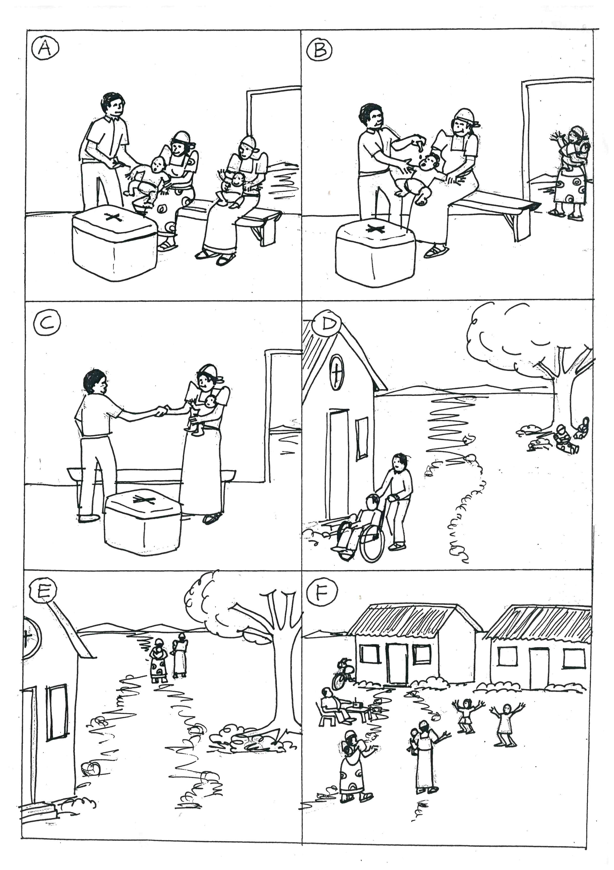

1. Picture A ………………………………………………………………………………………

……………………………………………………………………………………………………….

1. Picture B ………………………………………………………………………………………

……………………………………………………………………………………………………….

(c) Picture C ………………………………………………………………………………………

……………………………………………………………………………………………………….

(d) Picture D ………………………………………………………………………………………

……………………………………………………………………………………………………….

(e) Picture E ………………………………………………………………………………………

……………………………………………………………………………………………………….

(f) Picture F ………………………………………………………………………………………

………………………………………………………………………………………………………

(g) Where is the immunization of babies taking place in the picture?

. …………………………………………………………………………………………………

. …………………………………………………………………………………………………

(h) Who do you think the man being pushed in a wheelchair in picture

D is?

. …………………………………………………………………………………………………

. …………………………………………………………………………………………………

1. Why should the male nurse vaccinate the babies in pictures A and

B?

. …………………………………………………………………………………………………

. …………………………………………………………………………………………………

(j) Suggest a suitable title for the picture.

. …………………………………………………………………………………………………

. …………………………………………………………………………………………………

**\*\*\*THE END\*\*\***